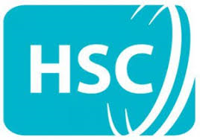
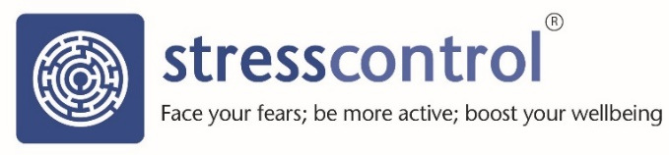
Stress Control online
Stress is a normal reaction to the rapidly changing and uncertain times we are all living in at the moment. If you are feeling a bit more stressed than usual and would like to learn some great ways, free-of-charge, to deal with common problems like anxiety, depression, panicky feelings, poor sleep and poor wellbeing then come along to our online Stress Control class.
‘Stress Control’ is a six-session cognitive-behavioural therapy class used extensively in community-settings by HSCNI and across the world. You can find out more here:
https://www.youtube.com/watch?v=TSwkQw2Jl7g
As you can’t come to a regular Stress Control class due to the current circumstances, Stress Control will come to you by live streaming two sessions a week on YouTube. Each session will repeat four times - for dates and times please see the session timetable on the website. The sessions will be led by Dr Jim White, consultant clinical psychologist, who created the class and who has taught most of the HSCNI (NI), NHS (UK) and HSE (Ireland) trainers who would normally be running classes in their communities.
To take part:
- Go to http://www.ni.stresscontrol.org where you can learn more about the class and get the dates. Everything you need to successfully complete the class – the booklets, self-assessment, relaxation and mindfulness - can be found in the ‘Free zone’. If you can, please read, and start working on, the ‘Preparing for the course’ booklets before Session 1. These can be found in the ‘Booklets’ section of the ‘Free zone’.

- On the homepage, click on the ‘Stress Control June’ link to access our YouTube channel where the classes will be available to view at the scheduled times. If you click the ‘Subscribe’ button on our YouTube page (free), you will receive notifications when a new session is available. You can also follow this link: https://www.youtube.com/channel/UCdCfzKgmXbB30baWLv6L5-g

- You do not need to register or login – please just follow the above link.

- The session will begin exactly on time, so make sure you are there from the start. Sessions run for about 90 minutes and there will be a 10-minute break in the middle. Due to copyright restrictions, sessions will only live stream so they will not remain on YouTube.

- The ‘Enhanced zone’ on the website is also available for those who want to do more, this will offer interactive session reviews, homework tasks, self-assessment and a much wider range of relaxation and mindfulness. There is a £20 fee to access the Enhanced Zone but everything you need to successfully complete the class is in the Free Zone.

- Each session is one piece of the jigsaw in tackling your stress. By coming to each class, the jigsaw will form, the big picture can emerge, and you will learn how to handle your stress better. This is cognitive-behavioural therapy so it is crucial you practice the skills you will learn between sessions.
Life is very hard for us just now and there are no easy solutions or magic cures, but, with hard work and determination, we can boost our resilience to cope with these difficult times and come out the other end stronger. Please pass this on to anyone who you think might benefit from the class.

