|  |
| --- |
| Safeguarding  &  Child Protection Policy  **Child Version**        **November 2023** |

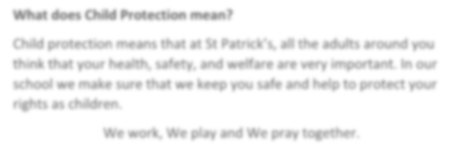

**What does Child Protection mean?**

Child protection means that at St Joseph’s, all the adults around you

think that your health, safety, and welfare are

very important. In our

school we make sure that we keep you safe and help to protect your

rights as children.

'Inspire, Believe, Achieve.'

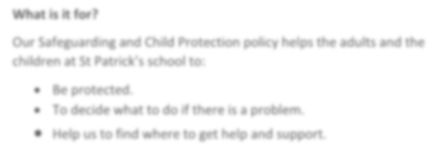

**What is it for?**

Our Safeguarding and Child Protection policy helps the adults and the

children at St Joseph’s school to:

•

Be protected.

•

To decide what to do if there is a problem.

•

Help us to find where to get help and support.

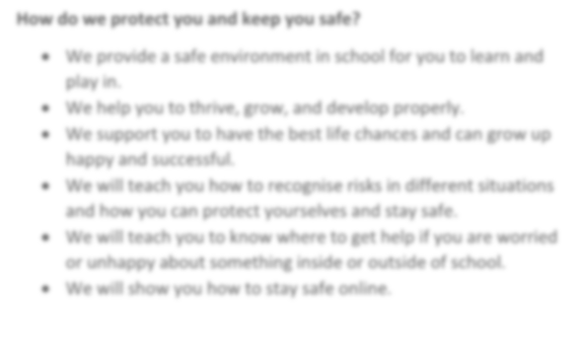

**How do we protect you and keep you safe?**

•

We provide a safe environment

in school

for you to learn and

play in

.

•

We help

you to

thrive, grow, and develop properly.

•

We

support

you

to

have the best life chances and can grow up

happy and successful.

•

We will teach you how to recognise risks in different situations

and how you can protect yourselves and stay safe

.

•

We will teach you to know where to get help if you are worried

or unhappy about something inside or outside of school.

•

We will show you how to stay safe online.

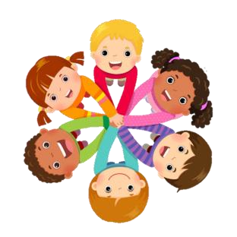

you safe and sometimes adults will talk to them if they are worried

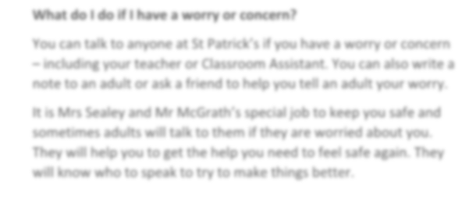

**What do I do if I have a worry or concern?**

You can talk to anyone at St

Joseph’s if you have a worry or concern

–

including your teacher or Classroom Assistant. You can also write a

note to an adult or ask a friend to help you tell an adult your worry.

It is Mrs Collin’s, Mrs Toner and Mrs MacFarlane’s special job to keep

about you. They will help you to get the help you need to feel

safe again. They will know who to speak to try to make things better.

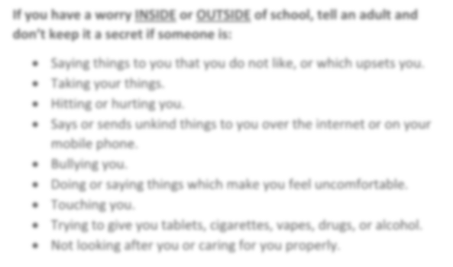

**If you have a worry**

**INSIDE**

**or**

**OUTSIDE**

**of school, tell an adult and**

**don’t keep it a secret if someone is:**

•

Saying things to you that you do not like, or which upsets you.

•

Taking your things

.

•

Hitting or hurting you

.

•

Says or sends unkind things to you over the internet or on your

mobile phone.

•

Bu

llying you

.

•

Doing or saying things which make you feel uncomfortable.

•

Touching you

.

•

Trying to give you tablets, cigarettes

, vapes

, drugs, or alcohol.

•

Not looking after you or caring for you properly

.

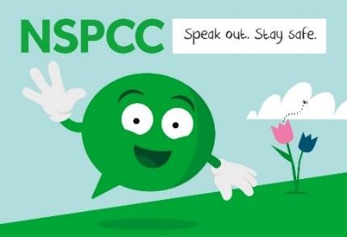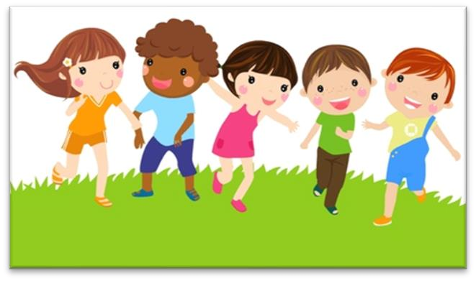

Here are some of the other people who can help you to keep safe if you don’t want to talk to anyone at school.

