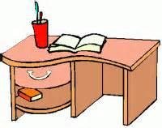
How to study at home

- Be ORGANISED, try to find a quiet well-lit place to sit and work and always have your books and materials ready for each subject you are going to study.

- Clear away anything that you do not need and any clutter.

- Turn of any distractions, TVs, Game consoles, Mobile Phones and only have any technology that you will be using to help you study and research. You can play games and talk to your friend during your time away from studying. , if using your mobile mute notifications while you study,

- Take plenty of breaks, remember at school you have break time and lunch time when you are able to exercise, eat something and give your brain a break. Think about a mobile phone where someone has been playing a game for a very long period and it gets very hot. Your brain is just like that and needs a rest. Work out a good balance between your studying and free time and start at a regular time and finish at a regular time every day, maintain that routine from Monday to Friday.

- Drink plenty of water, it will help hydrate your body and keep your brain active. Eat a good healthy balance diet too as you must feed your mind with healthy food as well as lots of information. If your diet is poor your body and mind will become sluggish and like poor internet that slows your PC/Tablet down poor food will slow you down.

