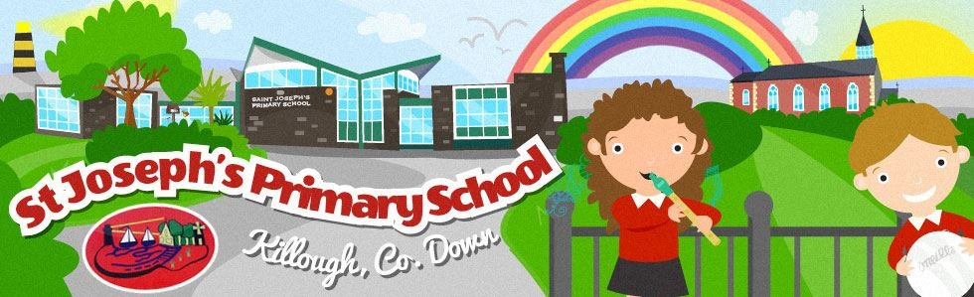
Holidays List 2022-2023
School begins for all pupils
Tuesday 30th August 2022
Tuesday 30th August and Wednesday 31st August school will close at 12pm as there are no school meals available.
Thursday 1st September, normal school hours will resume.
(P1 finish at midday until Friday 30th September, full day from Monday 3rd October 2022)

Teacher Training Day
Monday 26th September

Autumn Half Term
School finishes on Friday 28th October at 2:00pm
Monday 31st October to Friday 4rd November 2022 inclusive.
School reopens Monday 7th November 2022.

Christmas Holidays
School finishes on Wednesday 21st December at 11:00am
Thursday 22nd December to Thursday 5th January 2023 inclusive.
School reopens Thursday 5th January 2023.

Spring Half Term
Monday 13th February to Friday 17th February 2023 inclusive.

St Patrick’s Day
Friday 17th March 2023.

Easter Holidays
School finishes on Thursday 6th April at 11:00
Friday 7th April to Friday 14th April 2023 inclusive
School reopens Monday 17th April 2023.

May Bank Holidays
Monday 1st May 2023.
Monday 29th May 2021 to Friday 2nd June 2023 inclusive.
School reopens Monday 5th June 2023.

School finishes on Friday 30th June @ 11:00am
There will be NO After School Clubs or dinners on this day

Holidays should not be booked during term time

Dates above may be changed at short notice to facilitate staff training

