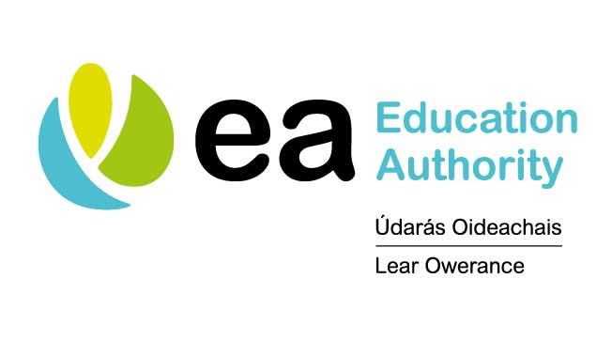
Re: The Addressing Bullying in Schools Safeguarding Survey

Under The Addressing Bullying in Schools Act, 2016, details of reported bullying behaviour and ongoing review of preventative strategies, are mandatory agenda items under the Safeguarding umbrella for school governors.
We would appreciate your support as parents and other stakeholders to complete a short survey to ensure you have a voice to inform our future training, resource development and support for schools.
We value your participation in this important exercise during difficult times and hope that it will ultimately lead to better support and safeguarding for our young people.
Please click on this link:
https://www.eani.org.uk/news/education-authority-are-reaching-out-
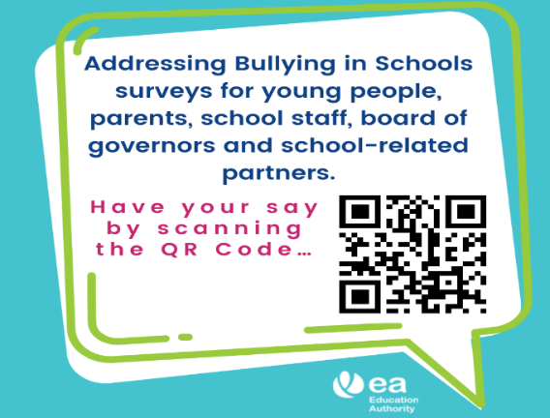

Addressing Bullying in Schools Act Implementation Team
Silverwood Centre, Lough Road, Lurgan, BT66 6LX
M: 07789550827 | T: 028 38314462 Ext:204462| E: absiteam@eani.org.uk

