**Remote Learning in Pre-School and Primary**

* **Last week, schools across Northern Ireland have set up an online support community on Twitter last week which can be accessed @learn_ni School principals and teachers are adding daily a range of resources, links and ideas to support each other with remote learning.**
* **Children thrive when there is a plan for the day or a daily schedule. It helps them to feel safe and secure. It is also very important that there is a balance between online learning, written and practical activities, outdoor learning and free time.**

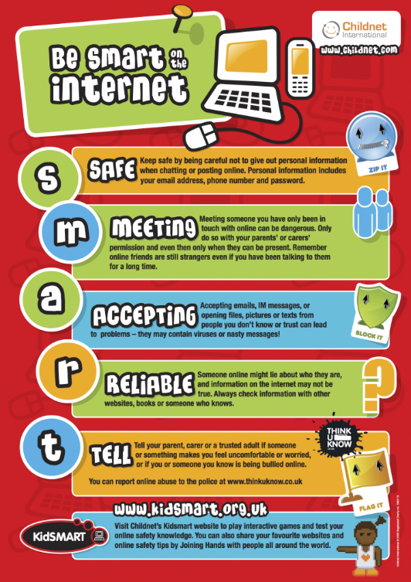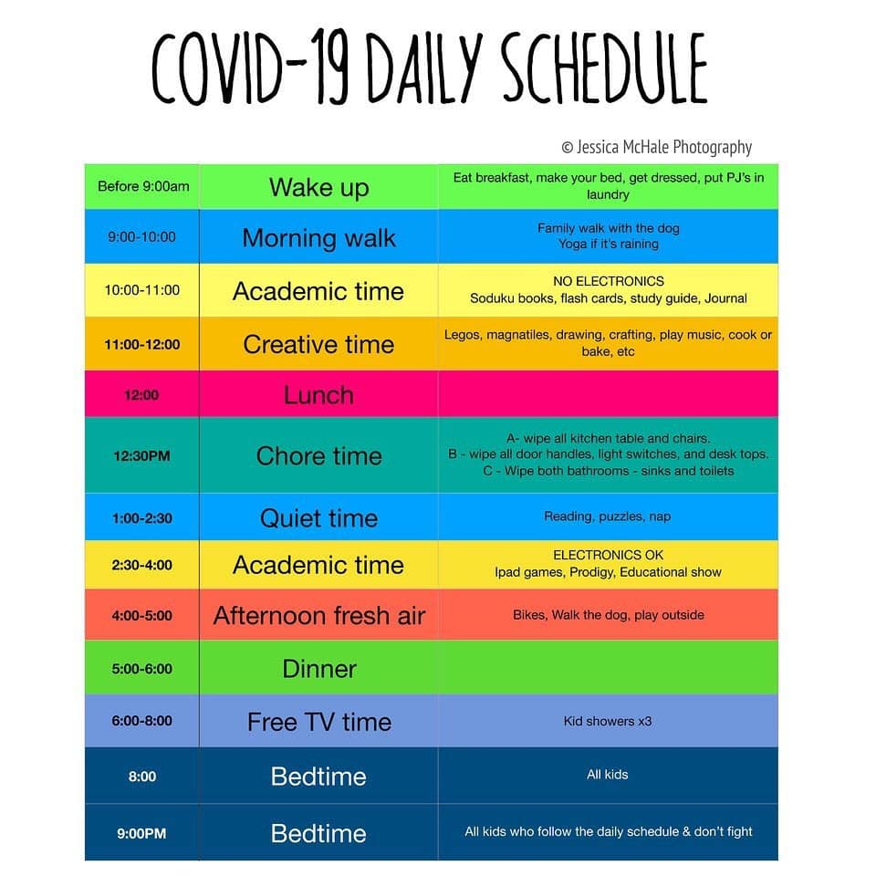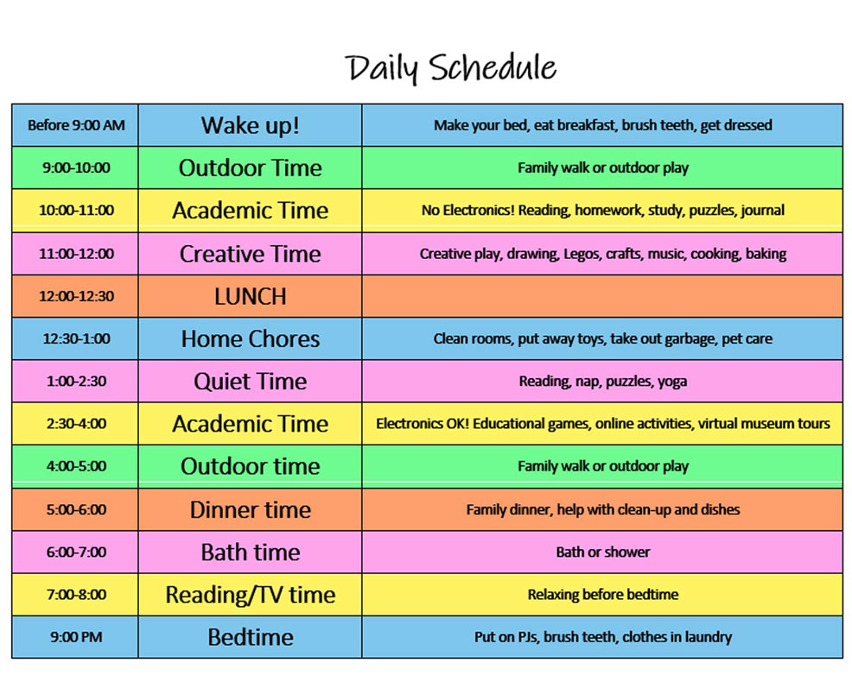

**Pre-School**

**Non-screen learning suggestions:**

* Getting Ready to Learn Book Bags
* Getting Ready to Learn Happy Healthy Kids physical equipment
* Outdoor physical activities
* Look at the wildlife, hedgerows and keep track of the changes in nature and photos and drawings
* Gardening activities- planting and digging
* Make models from junk materials, duplo, lego (see some suggestions for lego below- note American spelling)
* Cut and stick activities, paint and draw
* Fill a sink with water and engage in water play
* Play board games e.g. snap, Dobble
* **Bedtime box** *Suggested contents:* Teddy in box decorated as a bed; Blanket; Small toy for teddy; CD of bedtime songs and rhymes; Storybook – *Five Minutes Peace, Goodnight Moon, The Gruffalo, Goodnight, Little Bear*
* **Happy sack** *Suggested contents:* A selection of photographs of happy people/faces (or a variety of expressions for comparison/discussion); CD of happy songs and rhymes; Storybook – *I Feel Happy* ; Use phone to record happy sounds, laughing etc.
* **New baby box** *Suggested contents:* A baby doll; Box decorated as cot/cradle with blanket; Bottle, clothing and nappies; Storybook – *You’re the Biggest* (brilliant for new big brothers and sisters!
* **Playdough bag/box** *Suggested contents:* Recipe card so children can easily make it with some help (see recipe); shape cutters egg cups, plastic glasses and natural materials around the home and garden; range of tools for shaping and creating marks, using cooking utensils; special ingredients e.g. rice, glitter, spices and herbs.

**Recipe for playdough**

2 cups of plain flour

2 tablespoons of vegetable oil

½ cup of salt

2 tablespoons of cream of tartar

1 cup of water and food colouring, if desired.

* Bake and cook with adults
* Ideas to promote fine motor skills include scissor activities with dough, newspaper, old magazines and card.  As the skills progress change the thickness of the paper to make it more difficult and challenging by using former birthday cards and Christmas cards. Use household items like tongs and tweezers to lift sticks, cotton balls, small stones, etc.
* Don’t forget the gross motor skills.  Apart from the normal running and outdoor play, indoor activities could include: encourage children to bear walk, roll along the floor with arms tucked in and stretched out to strengthen core muscles, balancing/following on the lines on the tiles and using them to hopscotch and not forgetting to encourage using alternate feet on the stairs while counting
* Further ideas on app called *50 Things To Do Before You are Five* which is available on Google Play on the App Store.
* Further home learning ideas kindly supplied below by Pamela Algie, principal of Bangor Nursery School.

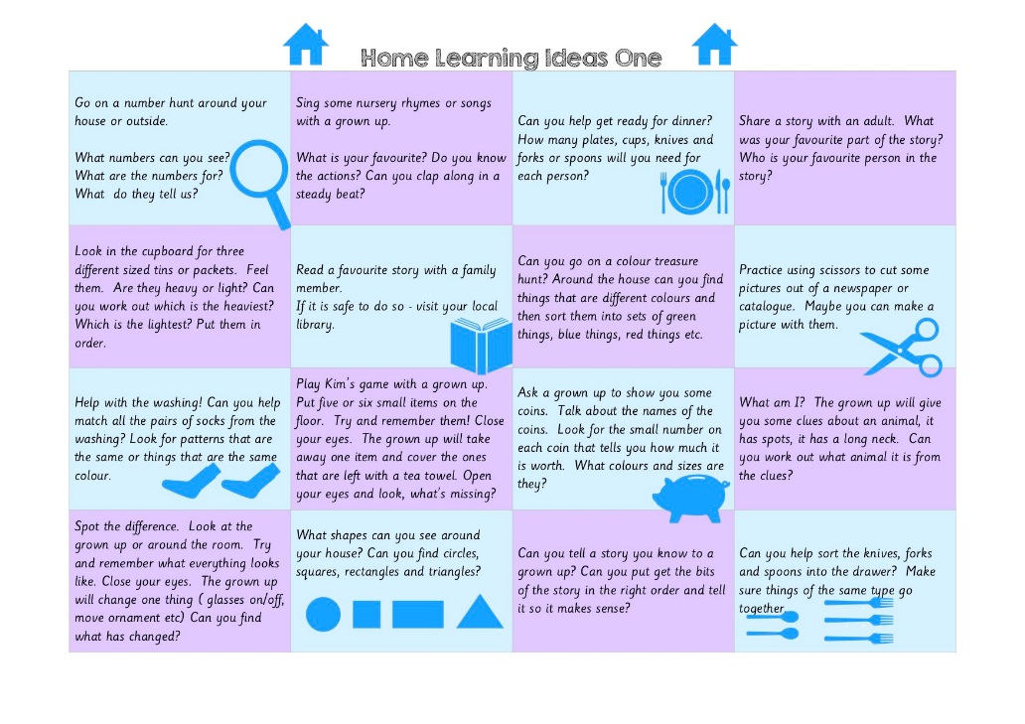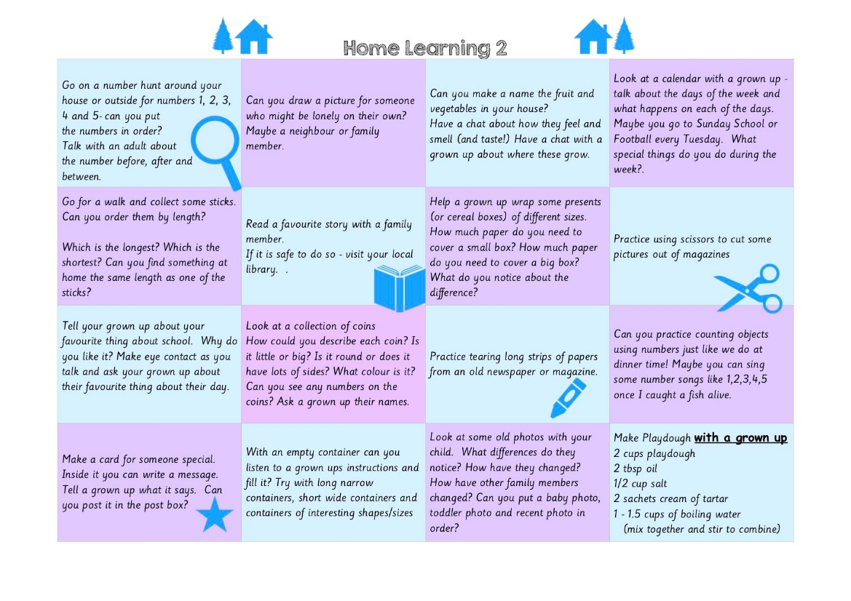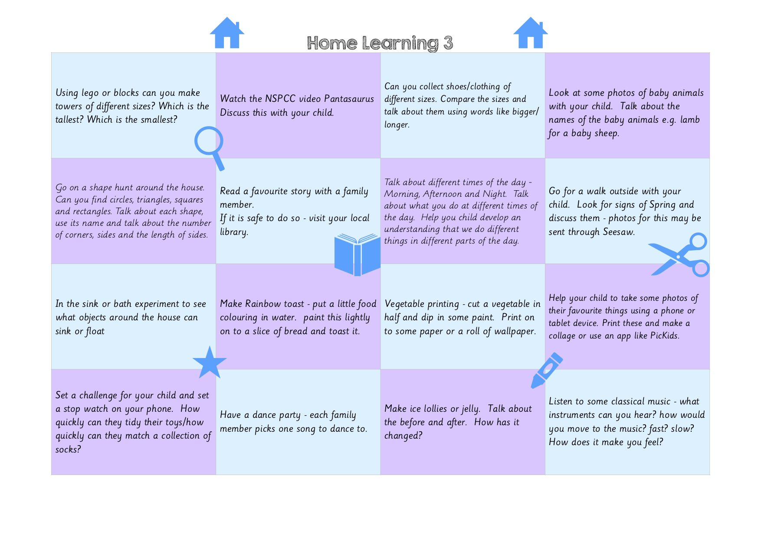

**Foundation Stage**

**Screen learning suggestions:**

* **Oxford Owl** (accessed at <https://www.oxfordowl.co.uk/for-home/?fbclid=lwAR0UL4FTi_mfFl_n3E1CP3emL->)A range of free eBooks for 3 – 11 years. Parents and teachers can register for free.
* **Guided reading activities** (attached) supplied by Karen Irwin and shared on Twitter @learn_ni
* **Teach Your Monster to Read** accessed at <https://www.teachyourmonstertoread.com> covers letters and sounds to reading full sentences.
* **Letters and Sounds Games** accessed at <https://www.topmarks.co.uk/english-games/5-7-years/letters-and-sounds> Phonics games which get progressively harder where children learn a range of skills from segmenting and blending and word comprehension to grapheme recognition.
* **New Phonics Play** can be accessed at <https://newphonicsplay.co.uk> The resources are free using the user name:march20 and password:home due to COVID19**.** There are a range of resources to practiseblending, segmenting, grapheme recognition and more.
* **Topmarks Counting Games** accessed at <https://www.topmarks.co.uk/maths-games/5-7-years/counting>
* **Maths Puzzles and Problems** for Years 1 and 2 (attached)
* **ICT Games** are on-screen games for literacy and numeracy at <https://www.ictgames.com/mobilePage/index.html>

**Non-screen learning suggestions:**

* Create a routine for the day using pictures/drawings/words
* Learn to ride a bike, bat/ball activities, skip, run, dig, hop
* Take a walk and look at the wildlife, hedgerows and keep track of the changes in nature and record findings in photos and drawings
* Gardening activities- planting and digging
* Keep a dairy/journal
* Make models from junk materials, duplo, lego (see some suggestions for lego below- note American spelling and some grammatical errors!)
* Play board games e.g. dominoes
* Bake and cook following recipes

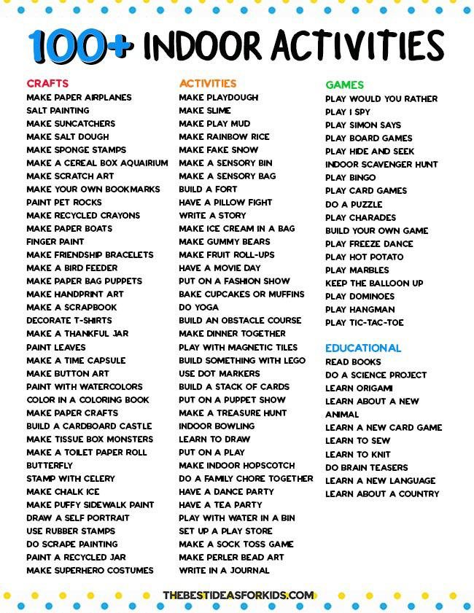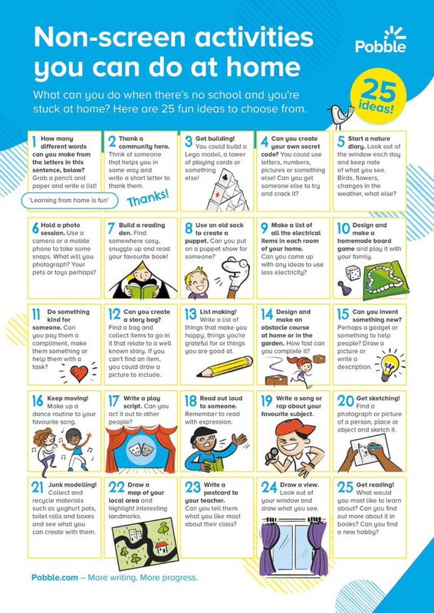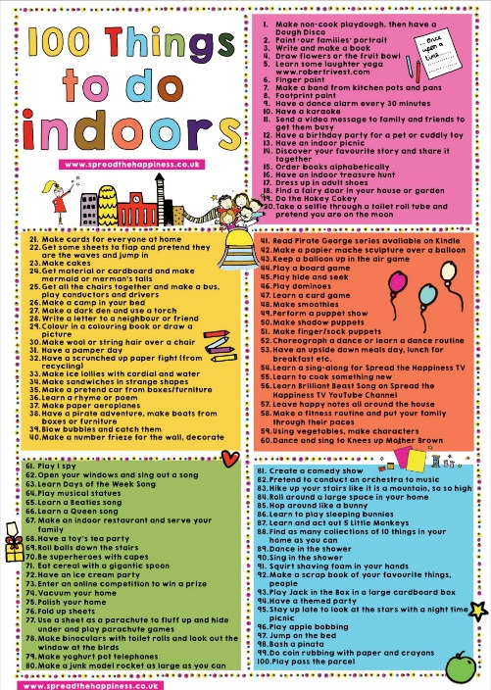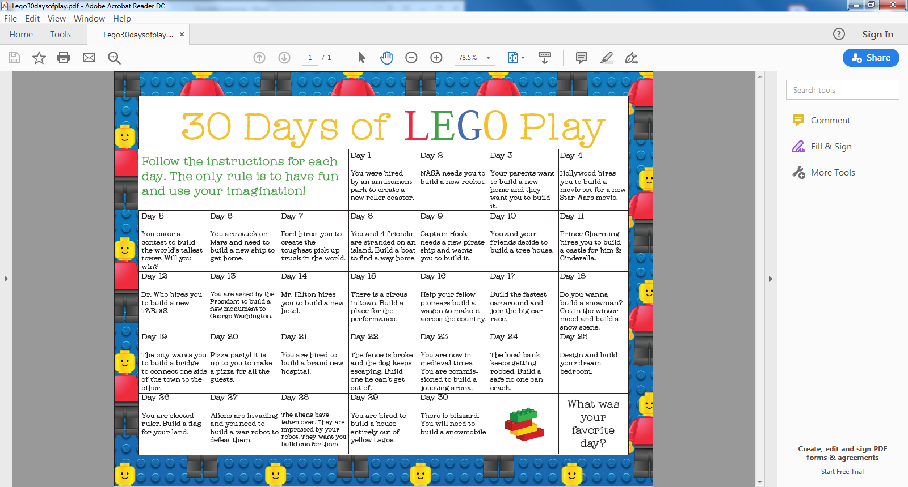

**Key Stages 1 and Key Stage 2**

**Screen learning suggestions:**

* **Microsoft 365 (C2K MySchool username and password required)**

**OneNote-** can be used to upload and store children’s work and provide written/audio feedback.

**Teams-** is a collaborative platform that combines chat, video calls and file storage. Use Teams to communicate with your class via video call or chat and store resources. Some schools are using Teams to set work for a group e.g. write a story in a group of six to enable children to work in groups and collaborate with their friends while working from home.

**FlipGrid-** is a video tool where children/teachers can record short video responses to collaborative class grids. It can be used to pose questions for children to answer/reflect/discuss a topic.

**Immersive Reader-** is supported in Word Online, OneNote, Outlook, and PowerPoint. Children can use Immersive Reader to hear the document read aloud, change the appearance of a document to help the reader focus on the content (increase/decrease text size, the amount of spacing between letters and words or the background colour of the document), identify parts of speech and a translate option.

**Office Lens-** can be used to scan a printed text and place it in OneNote — the program will use text recognition to launch the immersive reader.

* **Newsdesk (C2K MySchool username and password required)** Newsdesk is a very useful tool for schools to develop children’s fluency in reading, comprehension and writing skills. The Newsdesk Hour will be in operation from Monday 23 March where children can listen to interesting articles, watch video content and write about what they have read of learned. Children can also take a picture and upload it onto School Reporter section of the main Newsdesk site. The activities and topics are updated daily.
* **Collaborate Ultra (C2K MySchool username and password required)** video conferencing/virtual classroom. Collaborate Ultra can take up to 500 participants in any one session. Teachers can present slides, talk about learning, have children engage with the teacher etc. There is also the facility to have break out rooms. One teacher is sing Collaborate Ultra to support a child who has additional needs.
* **SeeSaw** can be used by teachers to engage with children and parents and to set and share work. Schools need to have an account with SeeSaw already.
* **Apple Camera And Clips-** free video apps to make professional videos that use graphics, effects and more. These tools can be used to create short and simple flipped videos to send to your class.
* **Explain Everything-** is an interactive app which can be used to create presentations, lessons and videos using drawing tools to illustrate or write a concept.
* **Purplemash** is available for free during the Coronavirus crisis. The site has resources for literacy and numeracy that can be pitched at many levels. <https://2simple.com/free-access/?campaign=3f314708-5ef0-11ea-9175-062a0562a518>
* **Oxford Owl** (accessed at <https://www.oxfordowl.co.uk/for-home/?fbclid=lwAR0UL4FTi_mfFl_n3E1CP3emL->)A range of free eBooks for 3 – 11 years. Parents and teachers can register for free.
* **Mashable** accessed at <https://mashable.com/2013/04/07/ebooks-for-children/?europe=true> 12 children’s e-books which can be downloaded free of charge.
* **NI Libraries** can be accessed at <https://librariesniuk.overdrive.com/> The website offers free eBooks and eMagazines.
* **Accelerated Reader (AR)** is a reading management and monitoring programme that aims to foster independent reading. The internet-based software assesses reading age, and suggests books that match childrens’ needs and interests. The children take computerised quizzes online once they complete the book. Please note, schools must have an account with Renaissance Learning in order to access this from home. This is not a free resource.
* **Lexia** is a spelling and reading programme. Schools must have an account before this can be used.
* **Guided reading activities** (attached) supplied by Michael O’Kane and shared on Twitter @learn_ni
* **INTO Film** can be accessed at <https://intofilm.org> have made member-facing activities freely available to all due to COVID-19. There are a range of primary age activities which include application of film knowledge, critical thinking and literacy skills.
* **ICT Games** are on-screen games for literacy and numeracy at <https://www.ictgames.com/mobilePage/index.html>
* **Number Fun**- Free of charge for one month and accessed at <https://parent.numberfunportal.com/free-account-page/> The portal contains over 200 song video presentations, accompanied by their respective resources for learning and teaching mathematics. There are four age ranges and nine themes in each age range to include: number and place value; addition and subtraction; multiplication and division; fractions, ratio and proportion; measurement; shape; position and direction; statistics; algebra; and, extras.
* **Time Tables Rock Stars**- free full access during COVID-19 outbreak which can be accessed at <https://ttrockstars.com/page/covid19support>
* **Learning by Questions** accessed at <https://www.lbq.org/Blog/using-lbq-for-distance-learning> is offering a free 60 day evaluation account in light of COVID-19.
* **Primary Games** accessed at <https://www.primarygames.com/math.php> Free maths games
* **Mathletics** is curriculum-aligned lessons and activities for numeracy. Schools must have an account before this can be used.
* **Maths Puzzles and Problems** for Years 3 - 7 (attached)
* **BBC Bitesize Primary** can be accessed at <https://bbc.co.uk/bitesize/primary> have a range of activities across all areas of the Northern Ireland Curriculum
* **BBC Super Movers-** free active learning programme for children in KS1 and KS2
* **Topic based projects** which can be shared through online learning platforms, the school app or website **DKfindout.com and Natgeokids.com** are useful websites for research for a World Around Us project. Some schools have ‘set’ a project within Teams for groups of children to collaborate on e.g. research all about a country.
* **Explorify** which can be accessed at[**h**ttps://explorify.wellcome.ac.uk](https://explorify.wellcome.ac.uk) Free resources to explore scientific concepts.
* **Natural History Museum** which can be accessed at <https://www.nhm.ac.uk/schools/teaching-resources.html> Free resources for the World Around Us programme.
* **Scratch** to develop interactive stories, games, and animations [https://scratch.mit.edu/ideas#](https://scratch.mit.edu/ideas)
* **Minecraf**t <http://www.nicurriculum.org.uk/STEMWorks/minecraft/> CCEA resource using Minecraft to explore the Vikings.
* **YouTube PE Skill School** Progressive and age/stage relevant Primary PE Challenges and most can be done at home with few resources.
* **Go Noodle-** free resources with movement and mindfulness videos created by child development experts available at https://www.gonoodle.com
* **YouTube Art for Kids Hub** Weekly ideas to ensure progression and appreciation of primary school art.
* **Tate Kids** which can be accessed at<https://www.tate.org.uk/kids> to explore art and artists.
* **The Kitchen Table Classroom: art and learning at home** <https://www.kitchentableclassroom.com/best-virtual-gallery-tours/> Take a virtual tour of famous art galleries.
* **The Worldwide Art Gallery** accessed at <http://www.theartgallery.com.au/KidsArt.html> Children can submit their art work for publication

**Non-screen learning suggestions:**

* Read a book
* Practise your musical instrument e.g. recorder, piano, violin flute etc.
* Dance or enjoy some yoga stretches
* Paint, draw or make a model from junk materials
* Play board games such as Monopoly or Trivial Pursuit
* Play card games such as Uno or Phase 10
* Bake or cook
* Go out into your garden and enjoy the fresh air- run, jump, skip, kick a ball, play tennis up against a wall

**Other online resources available for remote learning**

* Scholastic are offering free resources from PreK and Kindergarten to Grades 6+ which can be accessed at <http://classroommagazines.scholastic.com/support/learnathome.html> Please note spelling is American but some lovely stories to listen to, word match activities, quizzes and information about authors.
* TTS are offering free downloadable activity books for 5- 7 years and 7 – 11 years at <https://www.tts-group.co.uk/home+learning+activities.html>
* Oliver Jeffers, the children’s author from Belfast, has taken to the internet to do a live reading of one of his books each night and talking about where he got his ideas for the stories. The link to his readings can be found at <https://www.oliverjeffers.com/books#/abookaday/>

