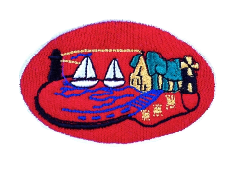

5th October 2020

Dear Parent/Guardian,

I wish to inform you that one member of our school community has been tested for Covid-19 and is awaiting the results.

Based on a risk assessment of the current situation and advice given by The Public Health Agency the school will remain closed to both staff and pupils tomorrow and Wednesday.

I will continue to monitor the situation carefully and provide a further update to parents tomorrow with regards to arrangements for the remainder of the week.

Parents with any questions or concerns are welcome to contact myself via email: fmacfarlane679@c2kni.net.

Please keep an eye on our school website, stjosephskillough.com, for further information and updates.

Kind regards,

Fiona Macfarlane (Principal)

