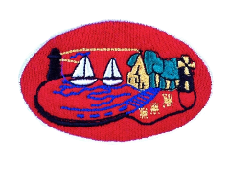
Dear Parents / Guardians

To celebrate the recent success for Down GAA and in anticipation for this Saturdays big final in Croke Park. We will be hosting a ‘Red Day’ this Wednesday, where we are encouraging all pupils to wear their Down GAA tops, jackets or anything RED into school. There may even be some very special guests joining us for the day. We ask that your child brings in a £1 donation as part of the student council fundraisers.

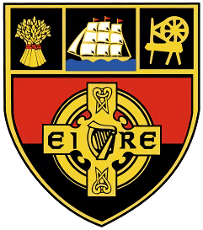
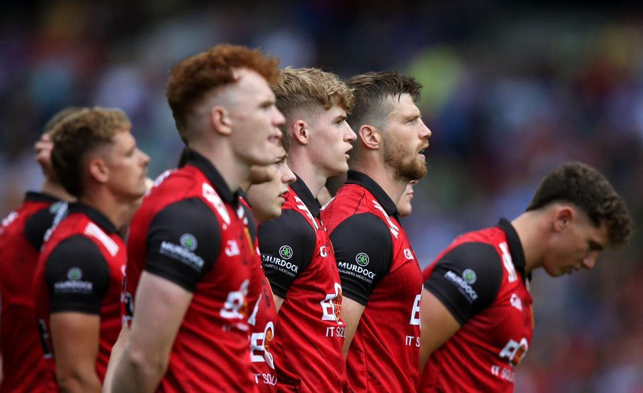

Kind Regards

Mr Rooney

